Middle East Technical University

Electrical and Electronics Engineering

EE463 Static Power Conversion

Project-1 Report



Student: Berkay SAĞLAM - 2031318

Sonay ULUKAYA - 2094597

Date: 25.11.2018

**Question 1**

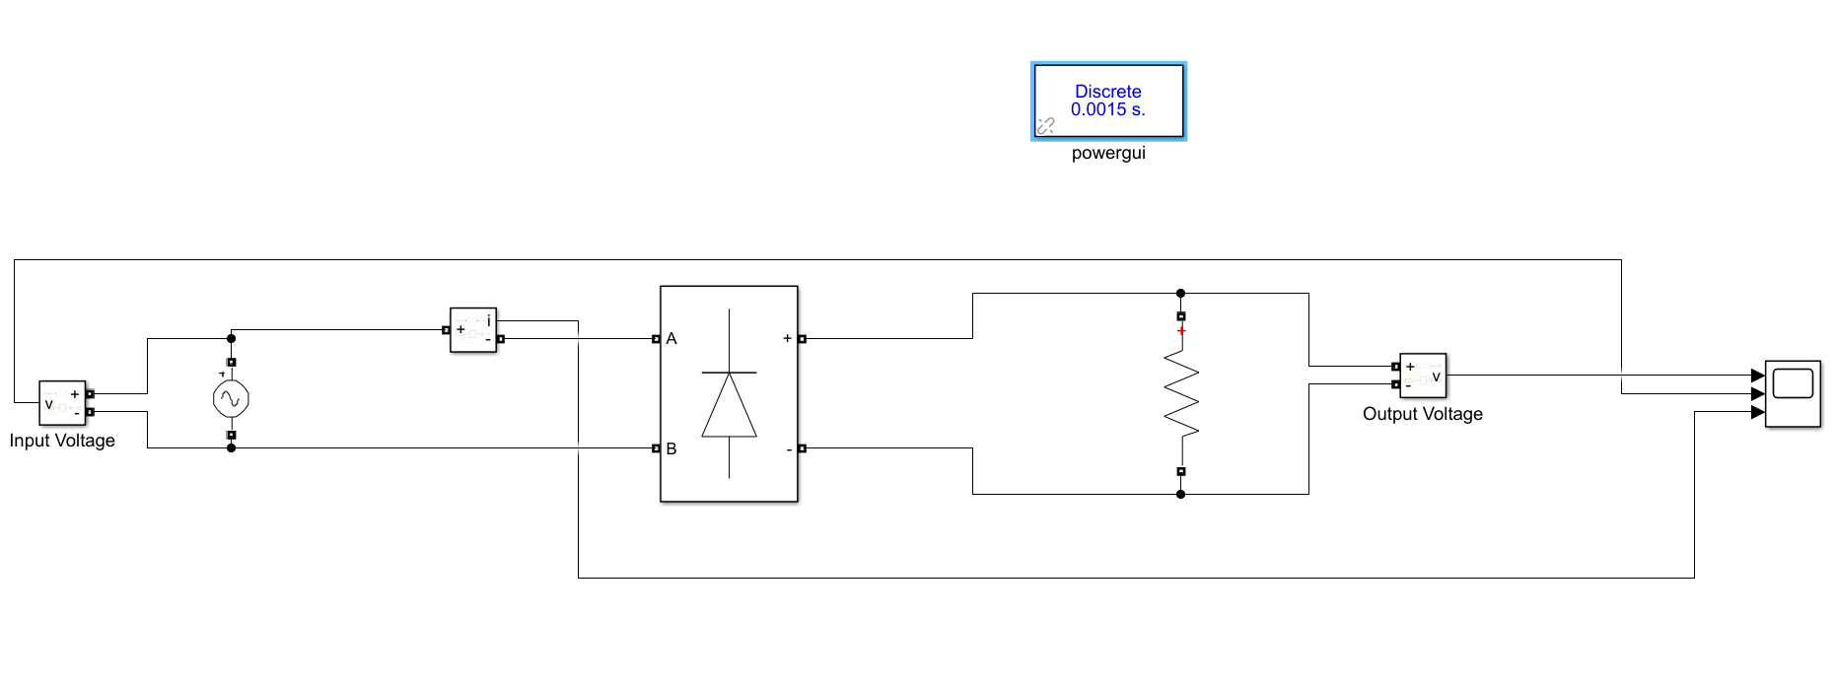

Figure 1: The circuit schematic of a single-phase diode rectifier feeding a resistive load of R = 100 Ω

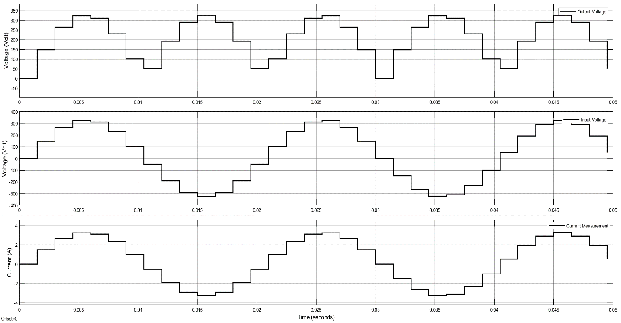

Figure 2: The simulation results for a single-phase diode rectifier when step size is 1.5 msec

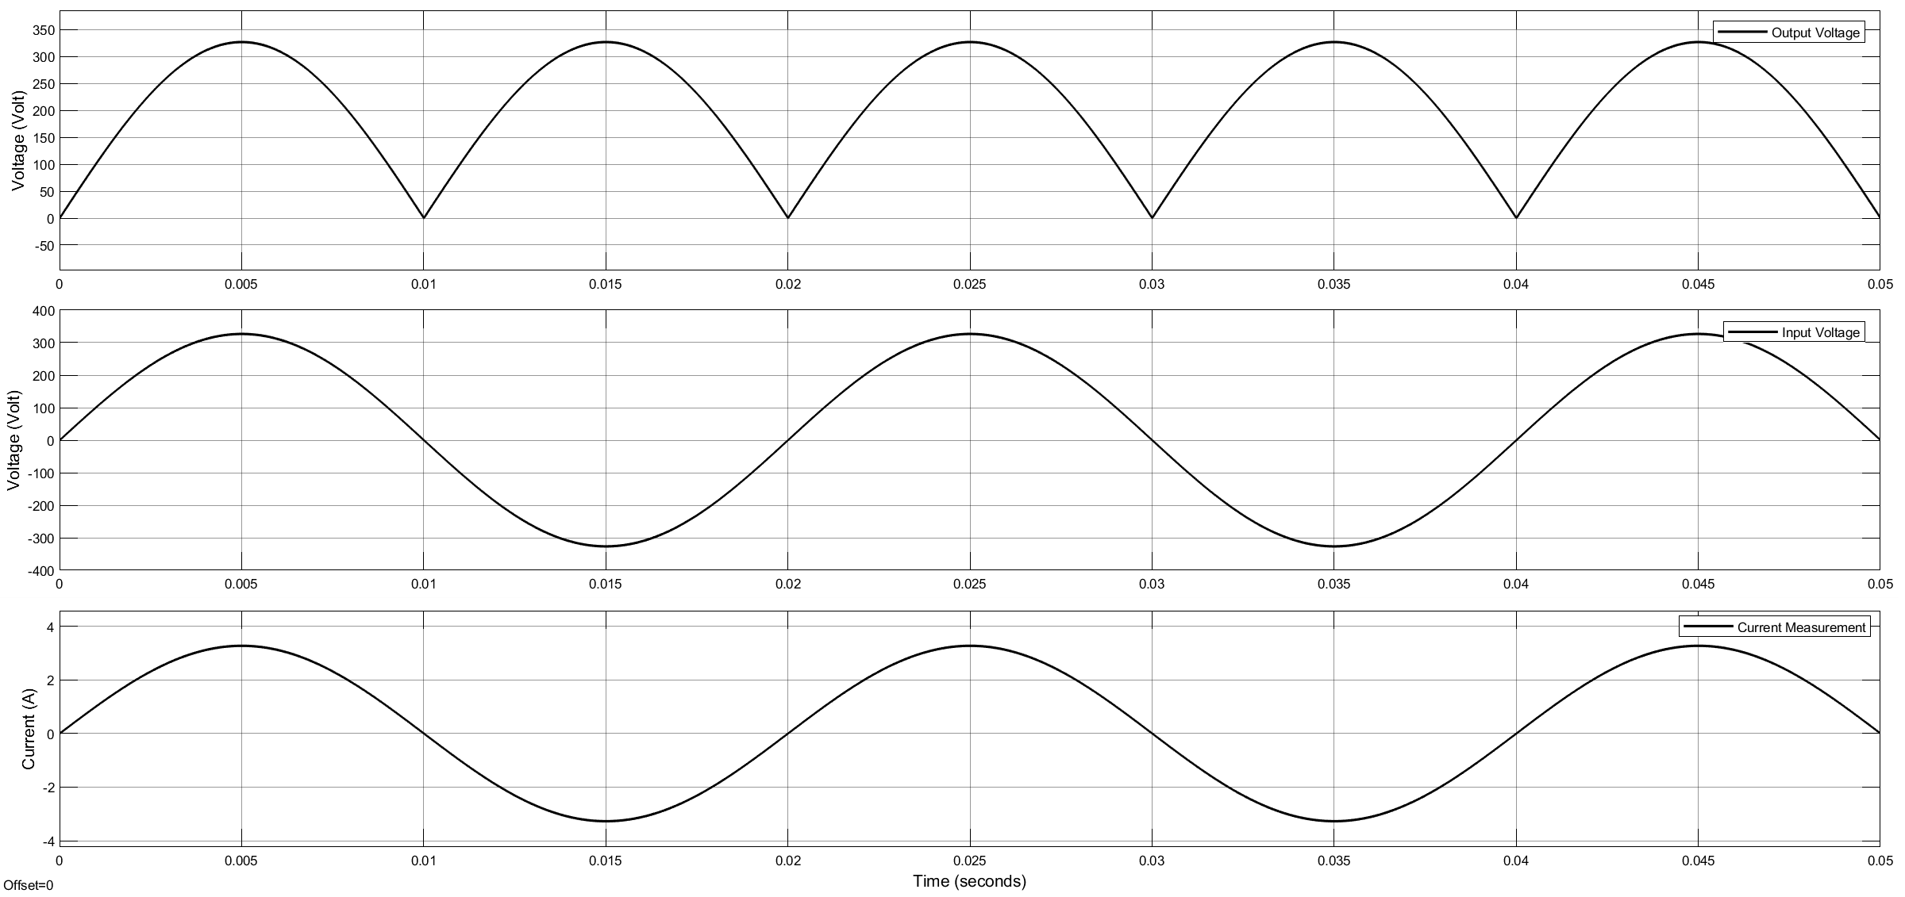

Figure 3: The simulation results for a single-phase diode rectifier when step size is 10 µsec

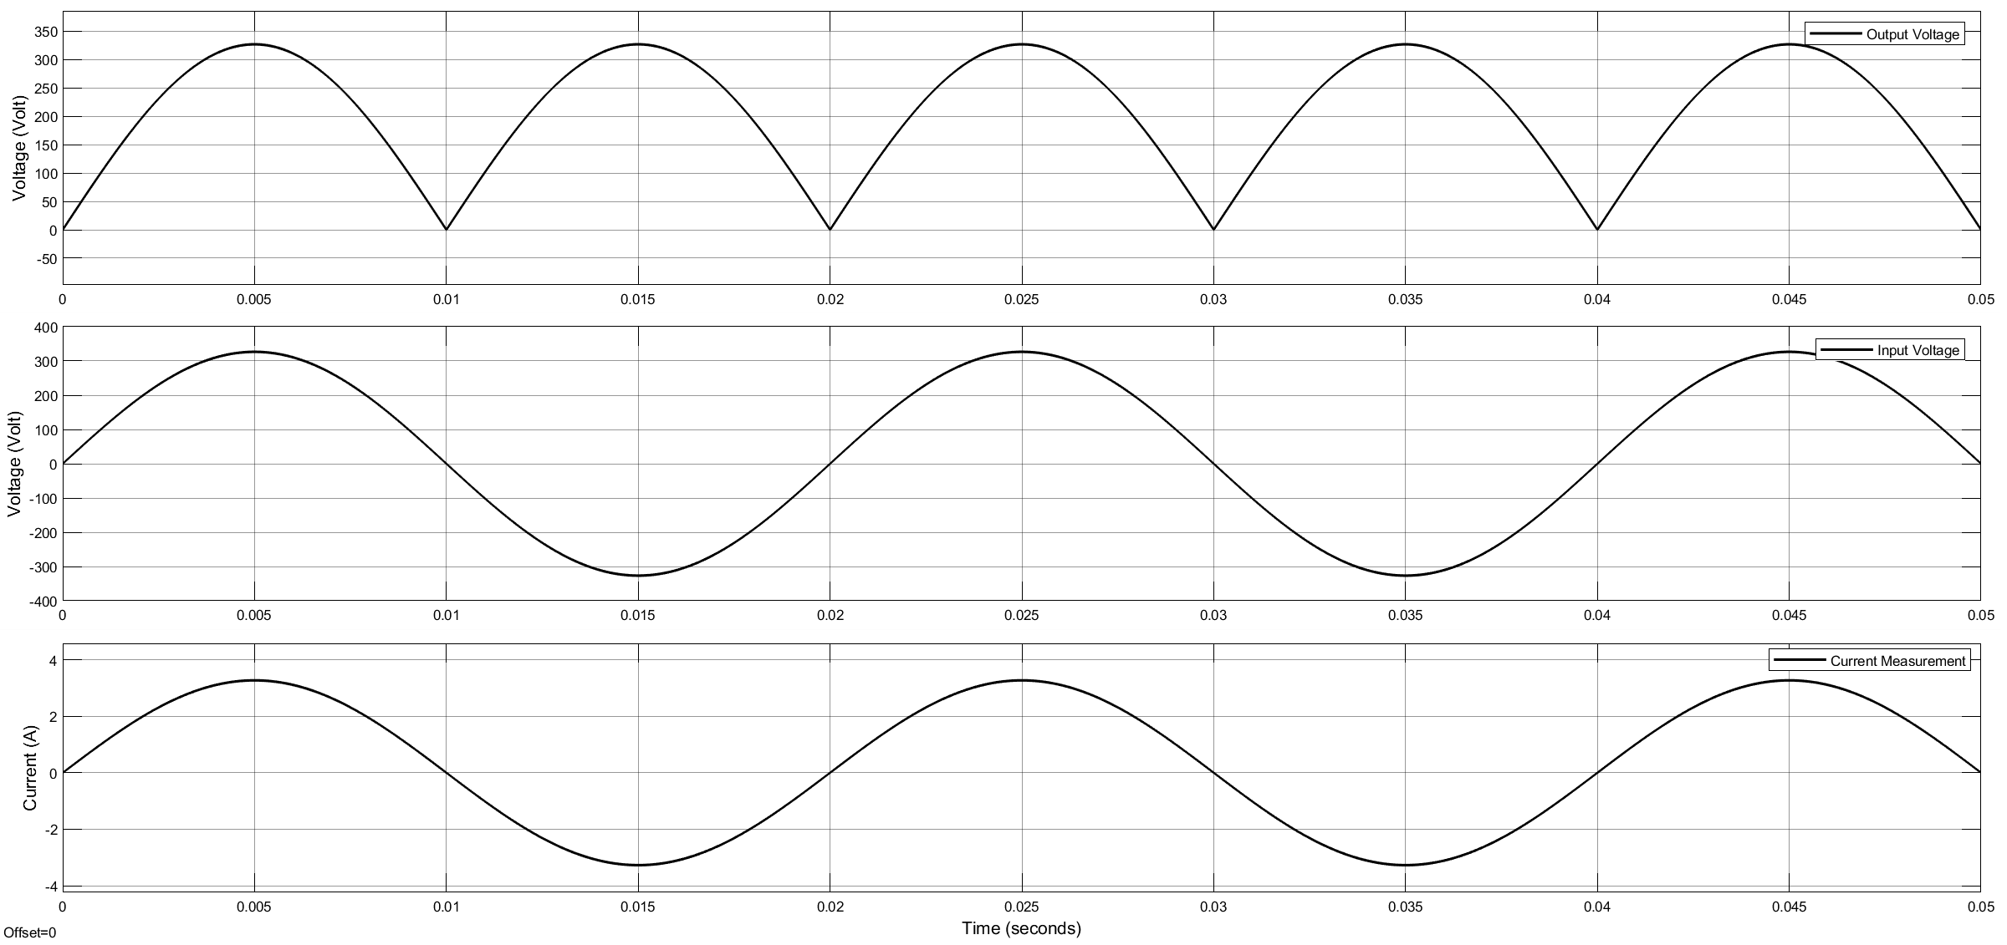

Figure 4: The simulation results for a single-phase diode rectifier when step size is 1 µsec

Step size is the time interval when computation happens for solver.Step size is the important property of solver because simulation results are affected by step size. A high step size will run quickly but take few data points and conversely a low step size will take many data points but take longer to run as a result. Whenever time step is not enough small, it can affect the consistency.In our question,when step size is selected to 1.5 msec,simulation takes shorter time ,but waveforms are distorted as you can see Figure 2.On the other hand, for 10 µsec and 1 µsec step sizes simulation results are more accurate and nearly same which can be seen in Figures 3 and 4, respectively. Difference is that simulation for 10 µsec takes a little bit longer time compared to 1 µsec ,but this is acceptable with respect to results.

**Question 2**

**Q2.1**

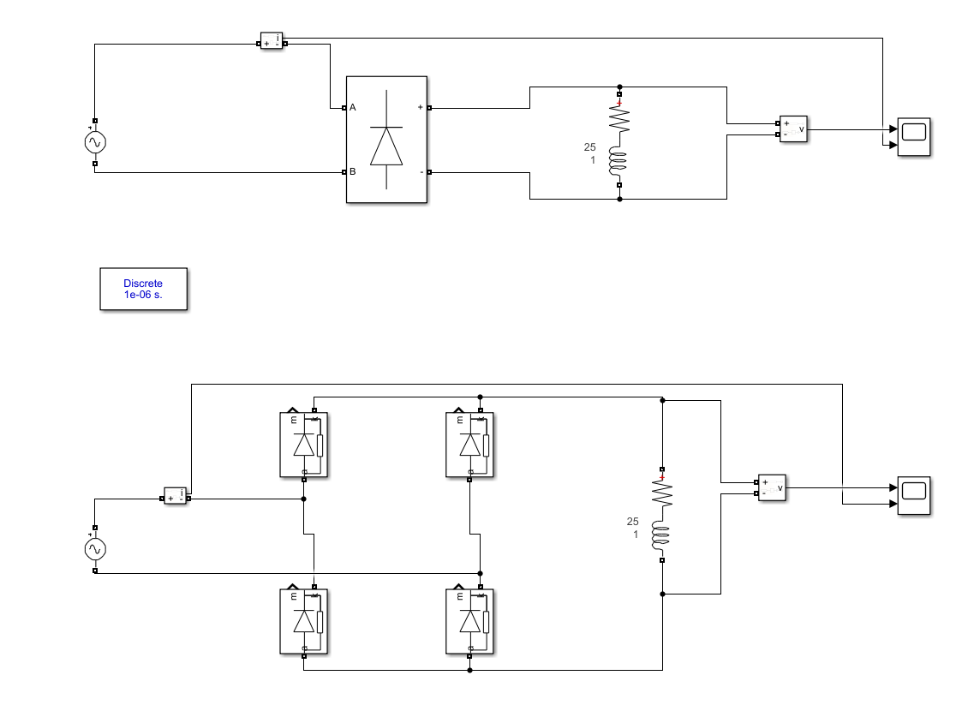

Figure 5: .Circuit schematic of diode rectifier with RL load.

1. A resistive load with R = 25 ohms

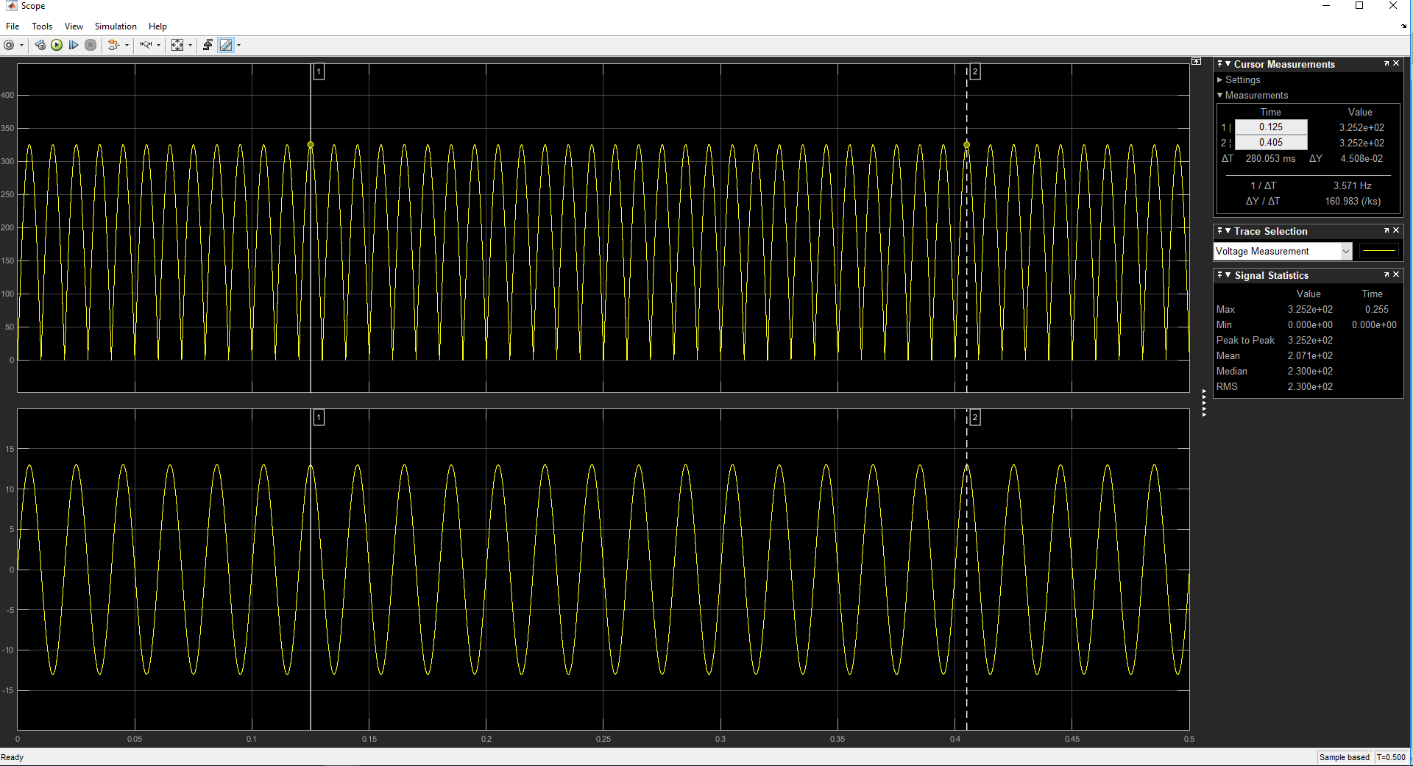

Figure 6 : Output voltage and line current waveform of desired load.

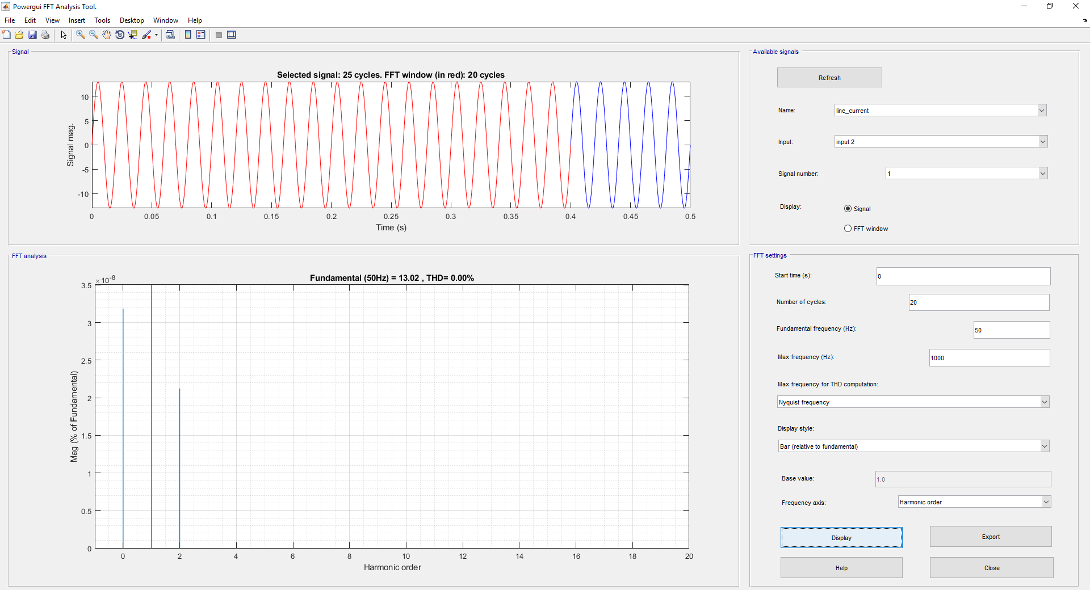

Figure 7 : THD of the line current.

1. An RL load of R = 25 and L = 10mH

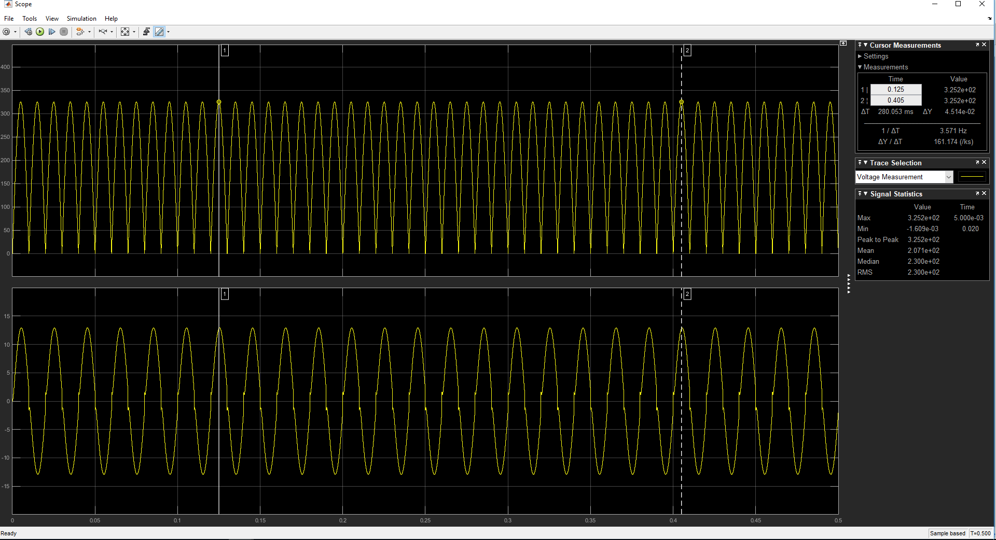

Figure 8 : Output voltage and line current waveform of desired load.

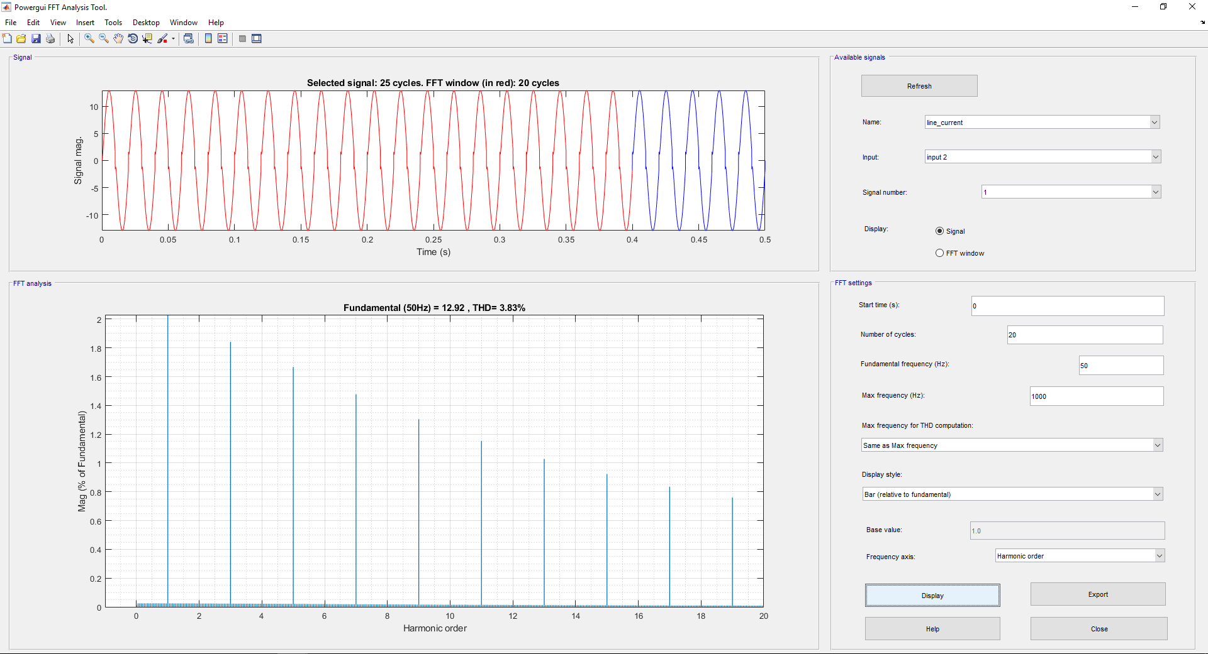

Figure 9 : THD of the line current.

As you can see, our line current waveform is changed due to the inductance.

1. An RL load of R = 25 and L = 1H

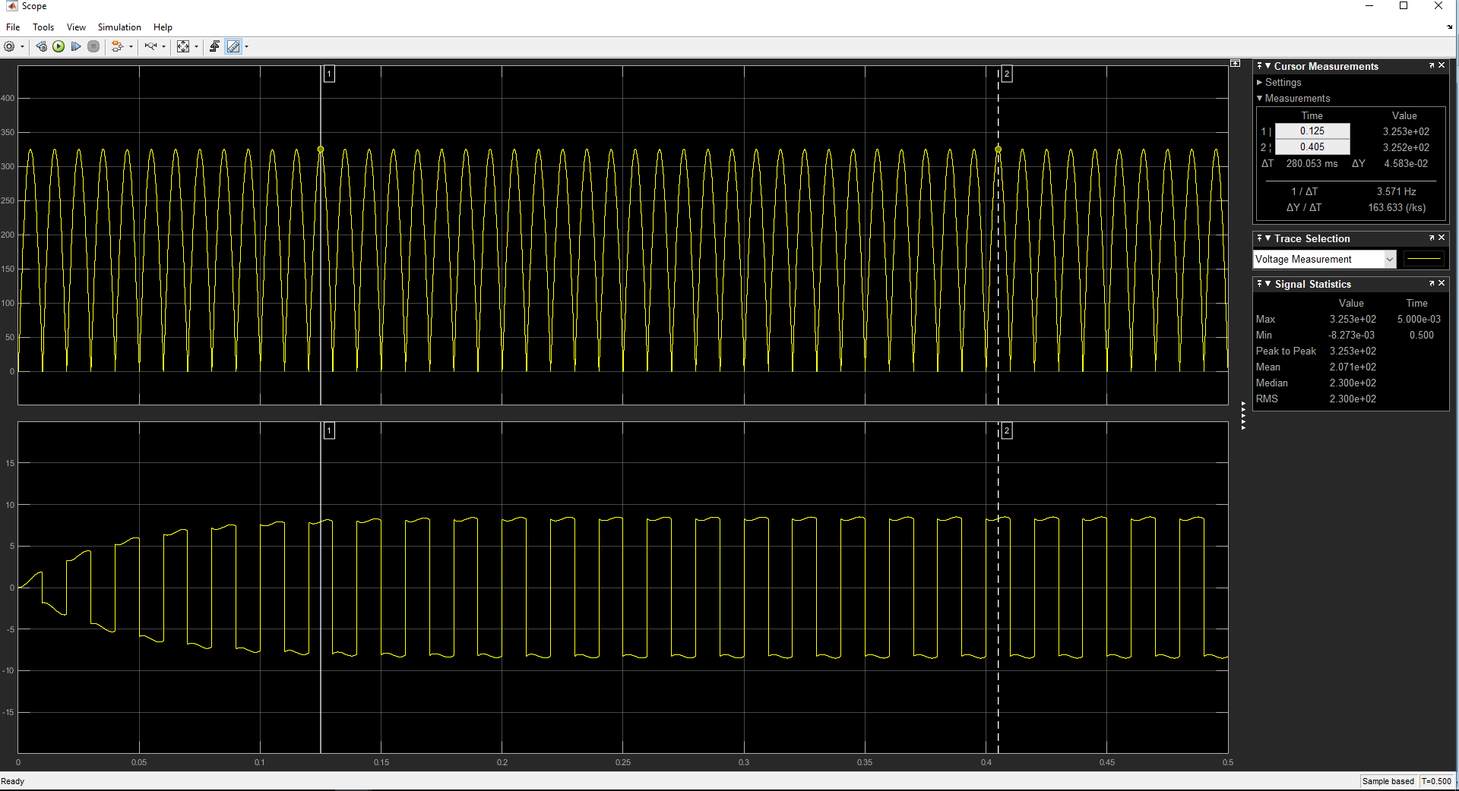

Figure 10 : Output voltage and line current waveform of desired load.

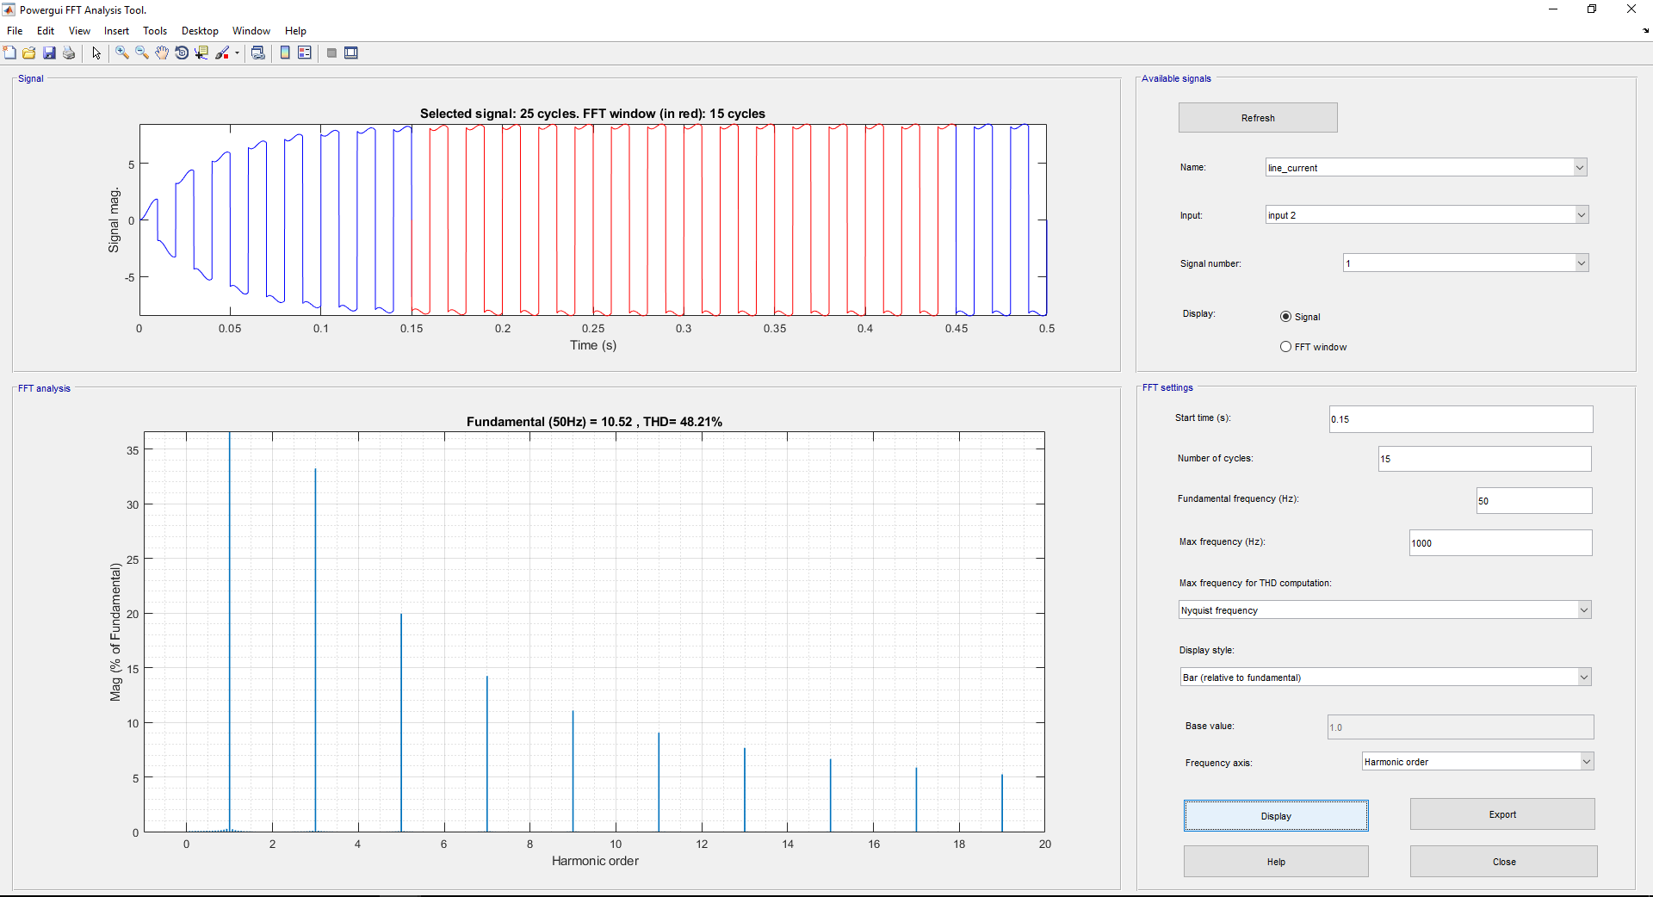

Figure 11 : THD of the line current.

In this part of the question, we can see that the current waveform has changed significantly.

The average voltage of three different types of load look as same. However, if we look deeply on the graphs, there are some slight increases. This is due to the voltage value of the inductors. The results of the graphs may differ by selecting a bridge rectifier or building it by diodes.

Secondly, THDs of these loads are different from one another. If only a resistive load is connected, our THD becomes nearly zero. The reason is that there would be no harmonics due to a resistance. The second and the third load type have an inductive load. These inductances causes the harmonics to occur. As we can see from the plots, if the inducance increases, THD will increase.

**Q2.2**

The ciritical part of choosing a diode or a bridge rectifier is reading the datasheets. There are some properties that we should take into account. One of them is the current rating. If we do not choose a valide current rating, our element would melt down and our circuit does not work. Second one of them is the breakdown voltage. The negative voltage applied in the element should not exceed. The last important factor is the forward voltage drop. Due to the internal conditions of diodes, there are voltage drops on them. These voltage drop might be significant if it is not taken into account. In other words, it effects the voltage waveform that passes through it.

There are some properties which are important like resistances and capacitances (i.e. Snubber capacitance). If we want to make our design work properly these properties should be at the desired range of operation.

By considering these properties, we choose the rectifier module which has   
GBPC1504DI-ND Digi-Key Part Number.

**Q2.3**

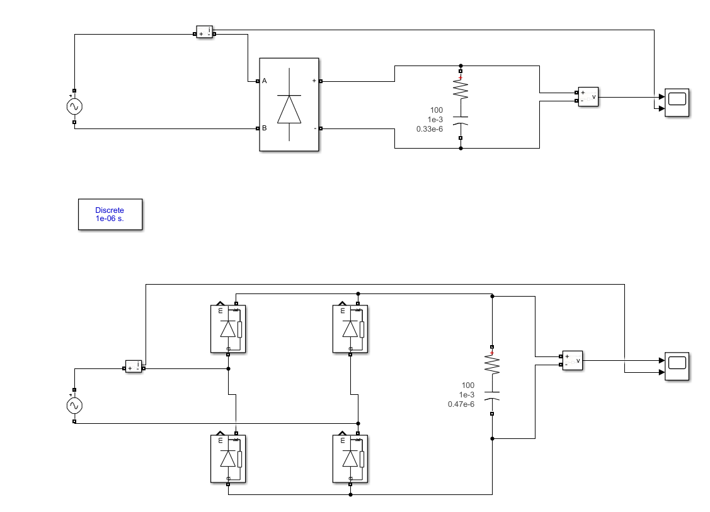

Figure 12 : Circuit schematic of diode rectifier with RC load.

For this circuit we found the suitable capacitor as 350nF by trying. The ripple that we get is 19,92% which is so close to 20%. The output voltage waveform ripples due to the capacitor. This capacitor stores the energy while charging and discharge itself when the ourput voltage starts to fall. After one cycle, capacitorstarts to charge itself again.

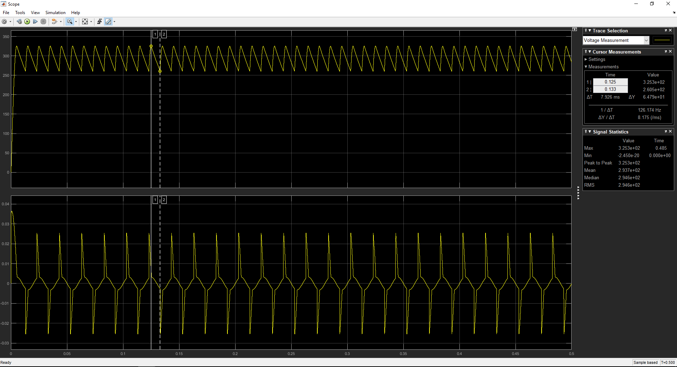

Figure 13 : Output voltage waveform when 350nF capcaitor is connected.

The figures below are for the commercial capaticors. The values for each of them are 330nF and 470nF respectively. The design which has 330nF capacitor does not fit the requirements with the ripple of 21%. On the other hand, the other design which has 470nF capacitor has 15,73% ripple which is suitable. The Digi-Key Part Number for chosen commercial capacitor is 565-1216-ND

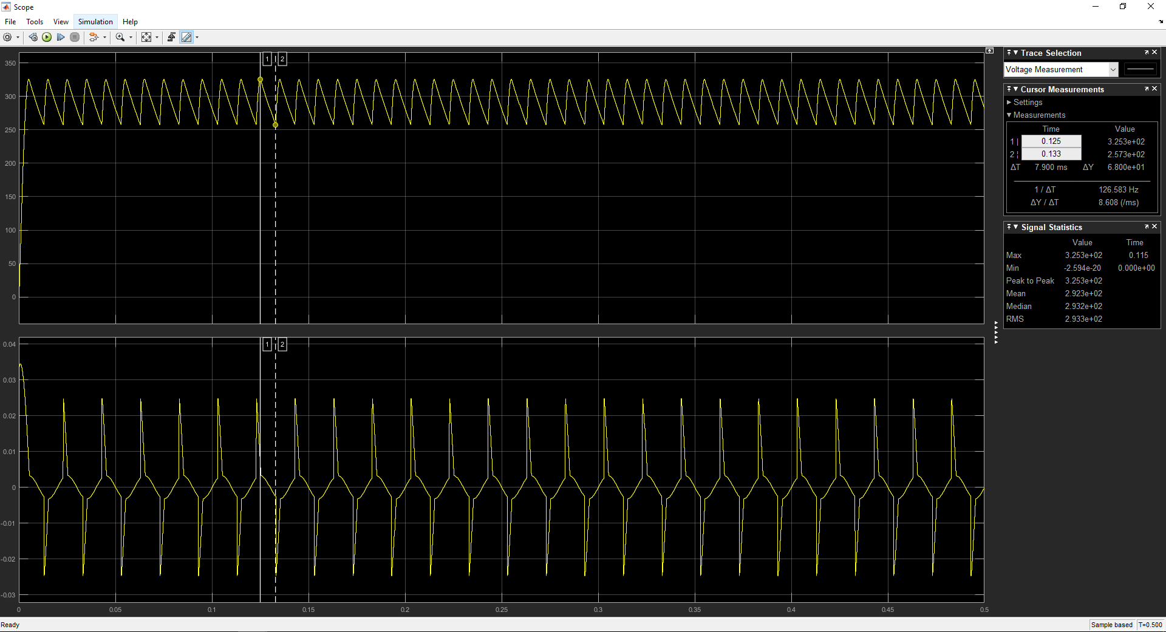

Figure 14 : Output voltage waveform when 330nF capacitor is connected.

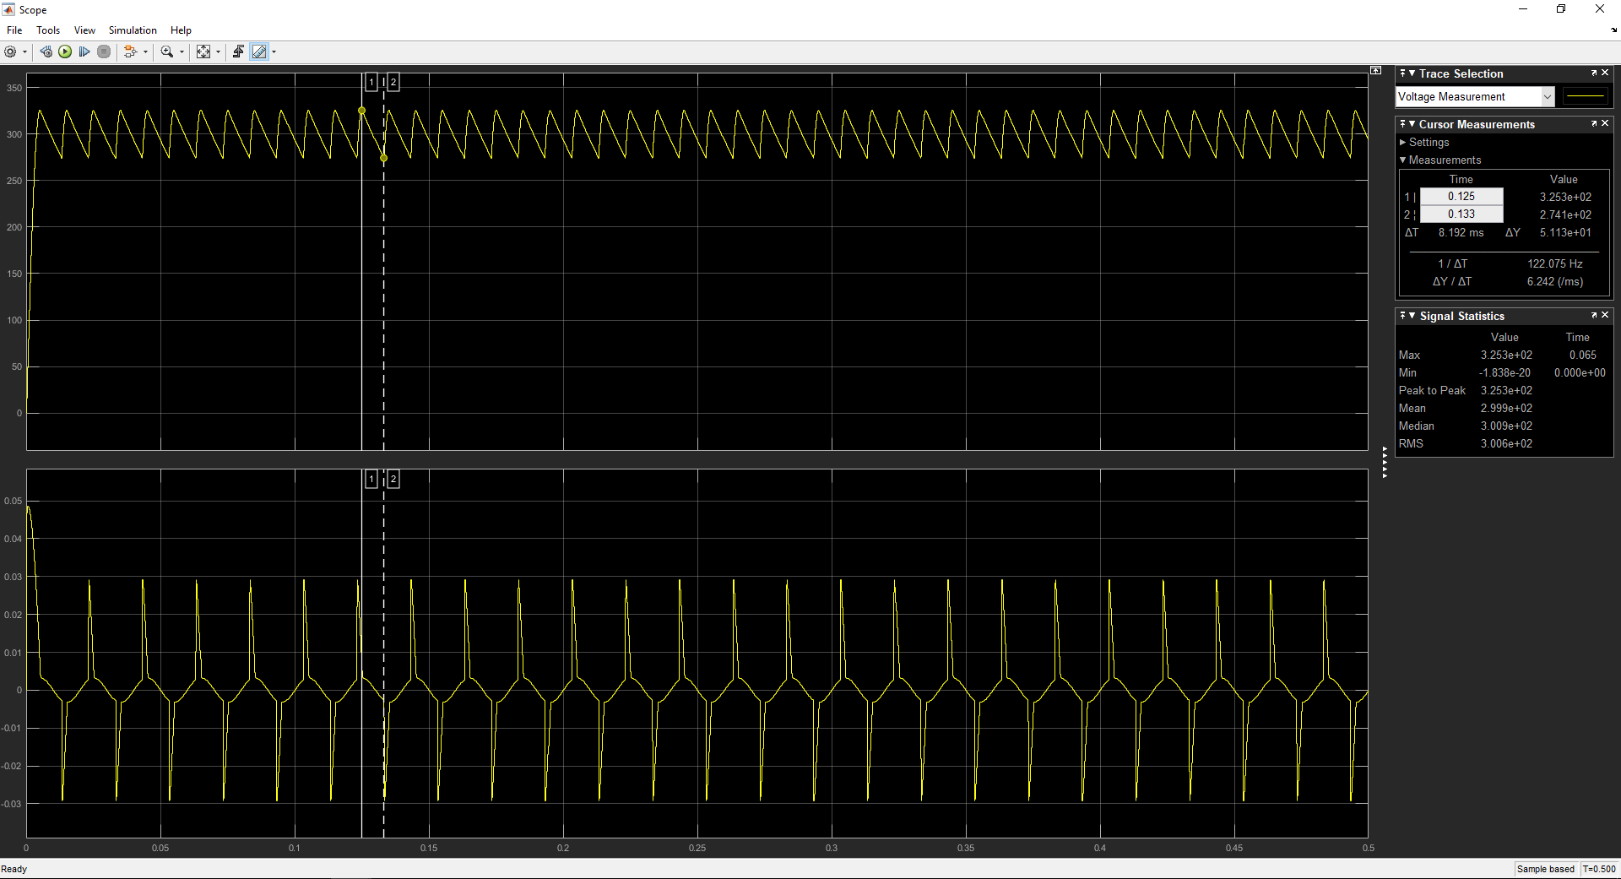

Figure 15 : Output voltage waveform when 470nF capacitor is connected.

**Q2.4**

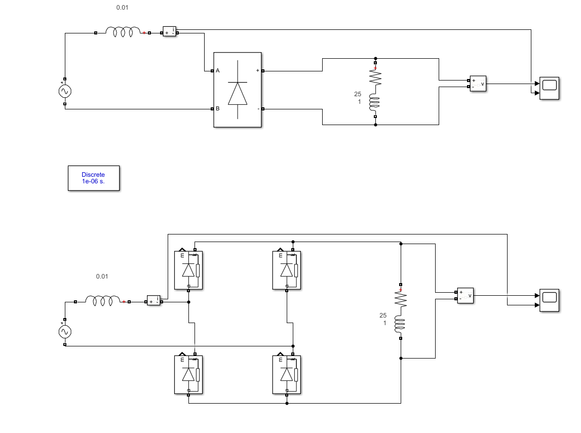

Figure 16 : Circuit schematic of diode rectifier with RL load and line inductance

In this part we added a line inductance to our design which has RL load of R = 25 ohms and L = 1H. If you look at the graph below, you can see that the output voltage waveform has changed. This change is due to the commutation. This comutation is caused by the line inductace that we added to our circuit. The commutation occurs when the current wants to flow but the other diodes opens at the same time. Then the flow of the current choose a different path and balance the circuit again. Secondly, the THD value of the line current is decreased.

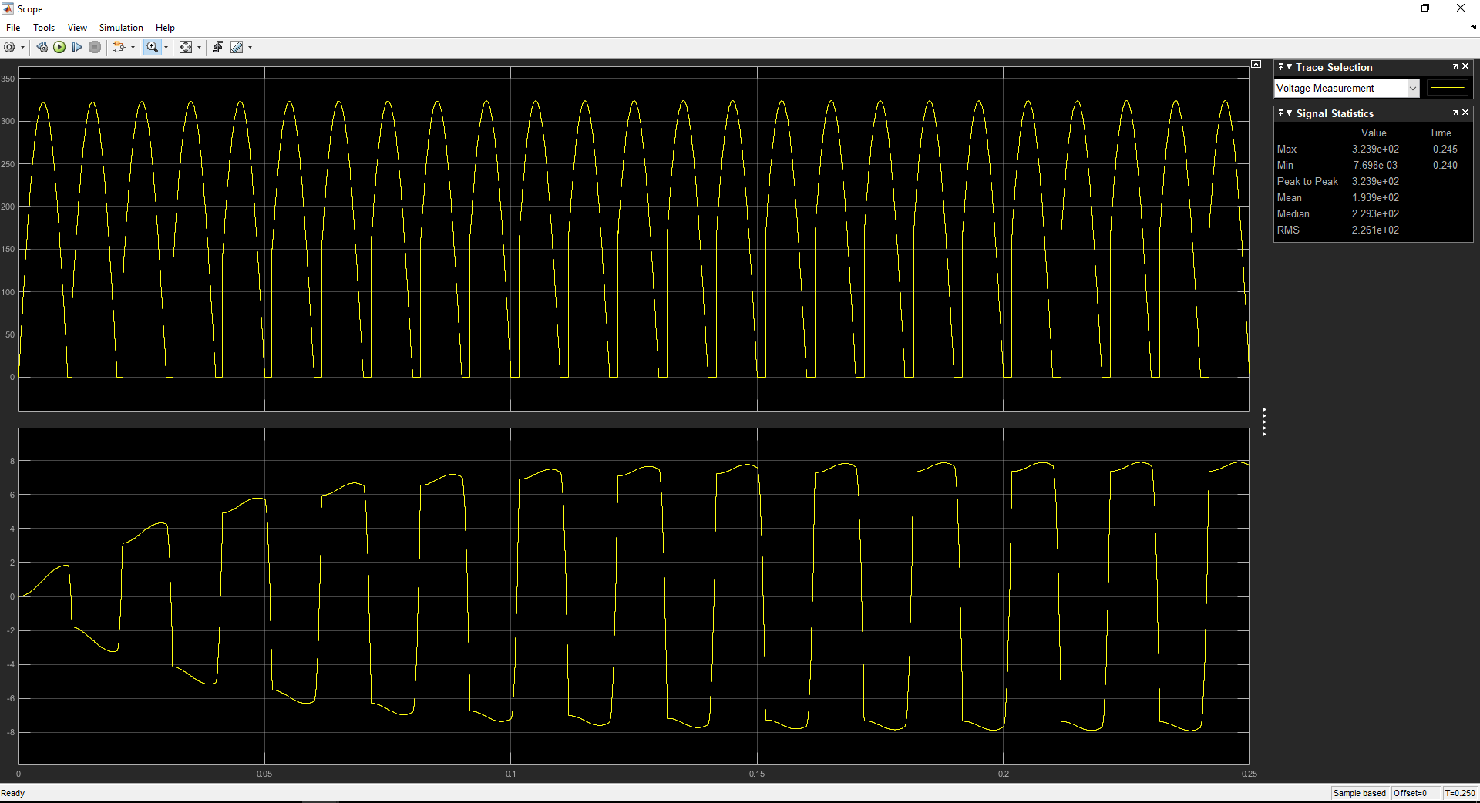

Figure 17 : Output voltage and line current waveform when line inductance is connected.

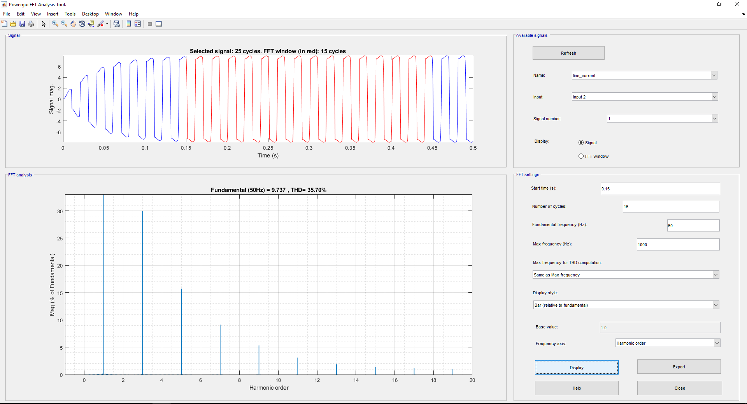

Figure 18 : THD of the line current when line inducance is connected.

**Q2.5**

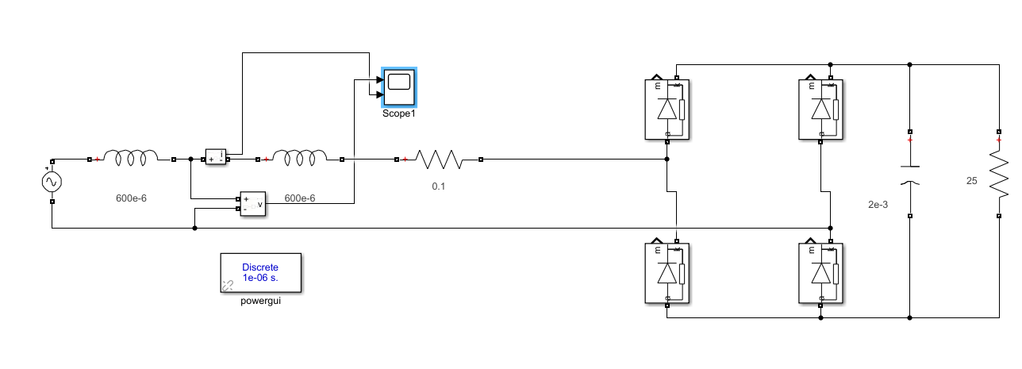

Figure 19 : Circuit schematic of line-voltage distortion circuit.

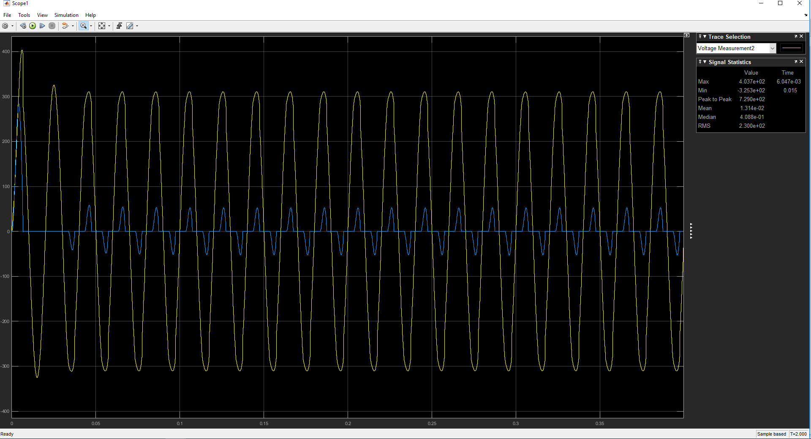

Figure 20 : Input voltage and current distorted waveforms.

Distorted currents drawn by the loads can result in distortion in the utility voltage waveform. As we change the load capacitance value, we can observe changes in the waveform. This concept should be taken into account when designing.

**Question 3**

**Q3.1**

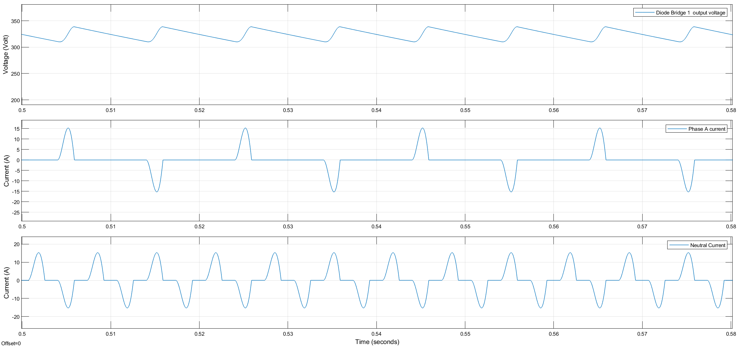

Figure 21 : The waveforms for Phase A current, neutral wire current and Diode Bridge 1 output voltage.

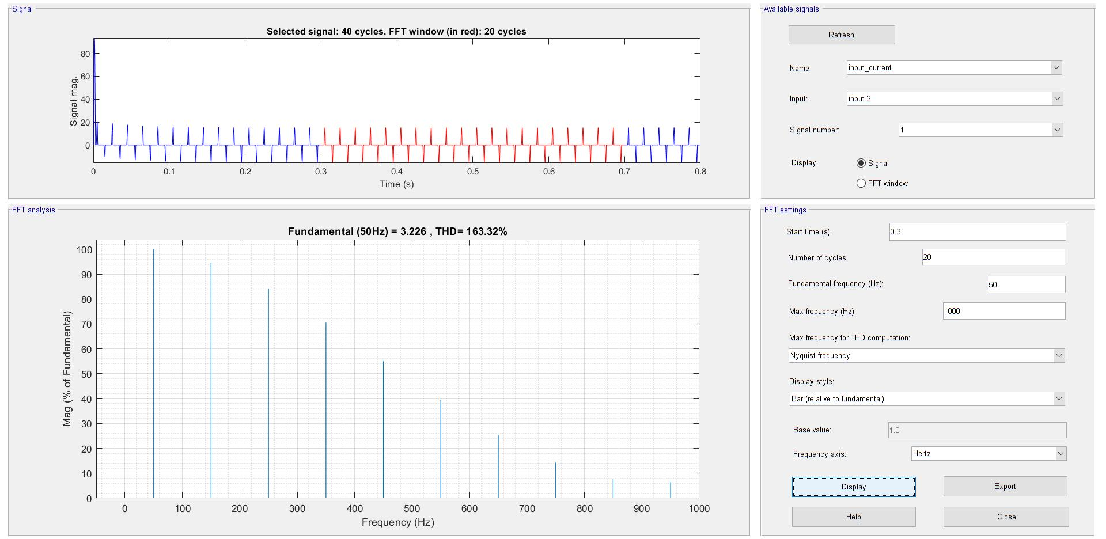

Figure 22 : THD of input current using FFT analysis, THD=163.32%

For power factor: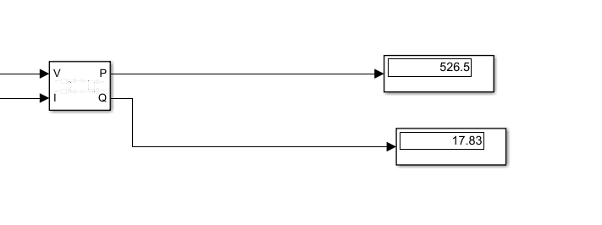

Using Power Measurement block, power factor was found 0.999 lagging.

**Q3.2**

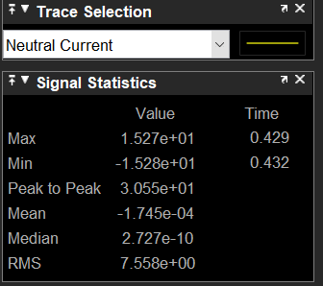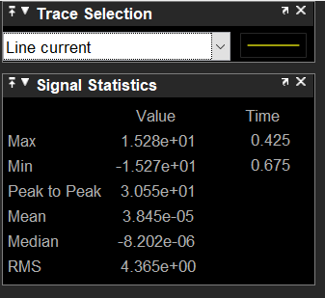

Figure 23: RMS values of line current and neutral current using Signal Statistics in the scope

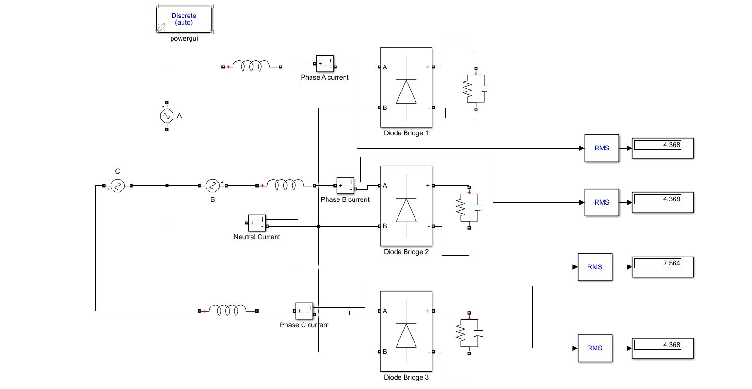

Figure 24: RMS values of line currents and neutral current using RMS block.

In this question, RMS values of line currents and neural current were founded by using two methods (RMS block and Signal Statistics in the scope). We obtained nearly same results for both of them. RMS values of line currents (A,B and C) are equal to each other and their RMS values are 4.36A approximately. RMS value of neutral current is nearly equal to 7.56 A and higher than line currents. All line currents pass through neutral wire. Thus, this results in that neutral current has higher value. Relationship between these values is nearly.

**Q3.3**

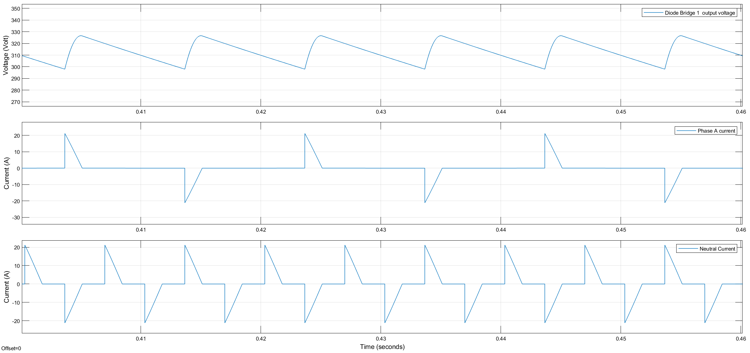

Figure 25 : The waveforms for Phase A current, neutral wire current and Diode Bridge 1 output voltage when Ls=0

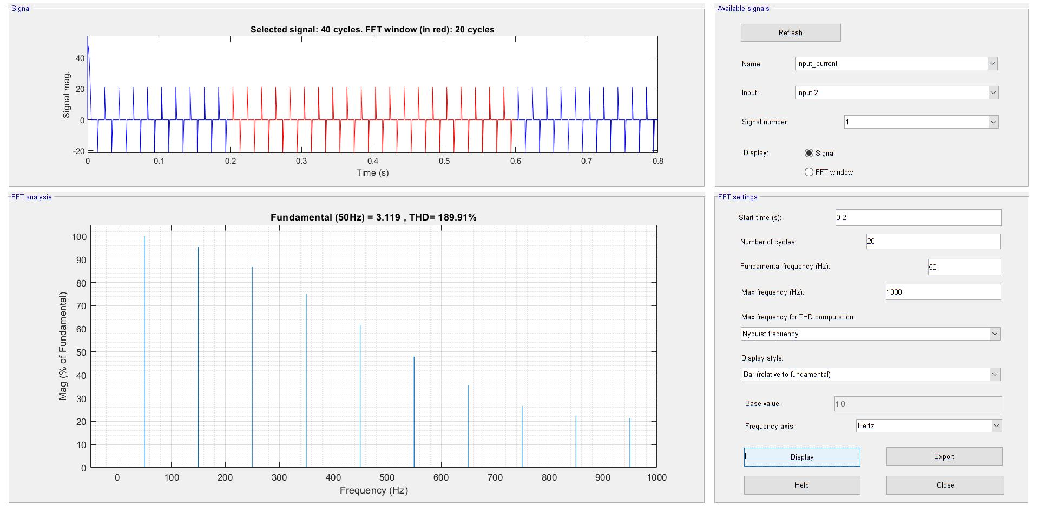

Figure 26 : THD of input current when Ls=0 using FFT analysis, THD=189.91%

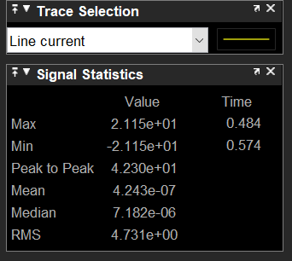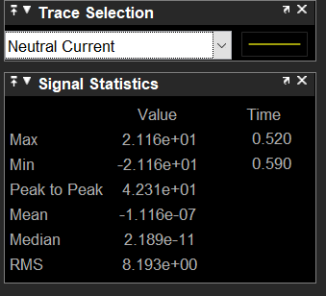

Figure 27: RMS values of line current and neutral current when Ls=0 using Signal Statistics in the scope

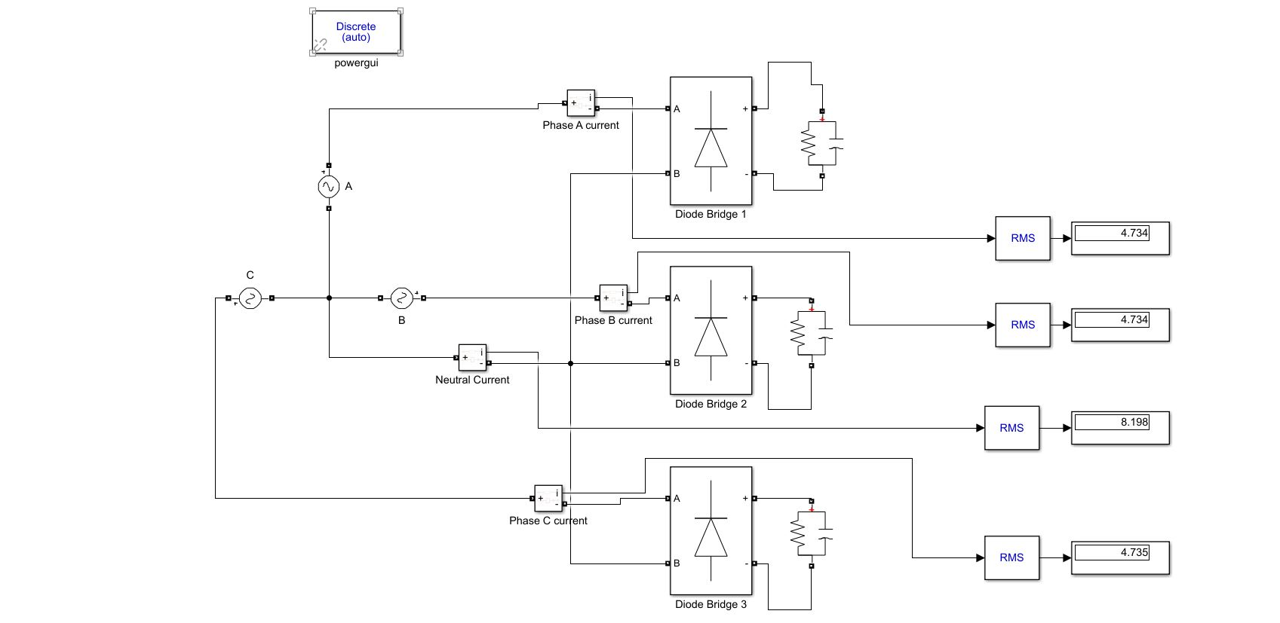

Figure 28: RMS values of line currents and neutral current when Ls=0 using RMS block.

For power factor: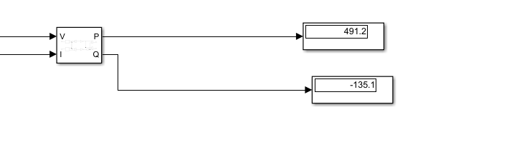

Using Power Measurement block, power factor was found 0.964 leading when Ls=0.

When we compare waveforms in Figure 1 and Figure 5, we observe that when Ls is equal to zero, transition of current waveform between the values is not instantaneous. However, current waveform does not change instantaneously when there is Ls during commutation. There is a finite time for transition between zero and maximum value of current waveforms. For V=L(di/dt) , the ‘di/dt’ term represents that the current passing through an inductor will not change suddenly.Depending on the value of inductor the shape of the current through inductor will change. Source inductance has a similar effect on the input current.

THD of input current waveform is lower in Figure 1, because THD of pure sine wave is zero and when there is Ls , waveform approaches sine wave. Thus, increasing Ls results in improved input current waveform with a lower THD.

Power factor is better when Ls is presented.In our 463 course ,we analyzed the relationship. For a given value of Id increasing Ls results in a smaller Ishort-circuit and hence a larger Id / Ishort-circuit . From PF vs. Id / Ishort-circuit graph , we have seen that larger Id / Ishort-circuit , or increasing Ls , results in a better power factor. Morover, from below equations we can understand that as THD decreases, power factor increases.